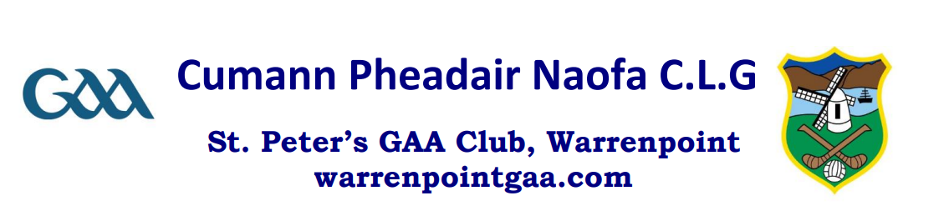

Cumann Pheadair Naofa GAA For All Inclusion Team are
inviting you to our open “Give it a go” session.

Where: St. Mark’s High School, Warrenpoint.

When: Sunday 14th April @ 10:30 - 11:30am

Why come along:

- Meet new friends
- Be part of a team.
- Learn new skills - not just football
- Play games
- To have fun, fun, fun!!!!

Our team gives everyone the opportunity to take part in GAA activities and skills.

We look forward to welcoming you all.

If we can be of any help, please do not hesitate to contact:

Declan Carvill
07763898688
declancarvill@yahoo.co.uk

